NESP Project Summary

This project aims to create a two-way communication between WiSA (Aqualink) and IrrigWeb, to allow the irrigation data being automatically uploaded to IrrigWeb for irrigation record keeping, and to allow automatically scheduling on Aqualink for better irrigation management.

This project consists of two parts: 1) Uplink, which automatically uploads irrigation data from Aqualink to IrrigWeb; and 2) Downlink, which automatically downloads irrigation schedules from IrrigWeb and apply them to Aqualink.

# Uplink

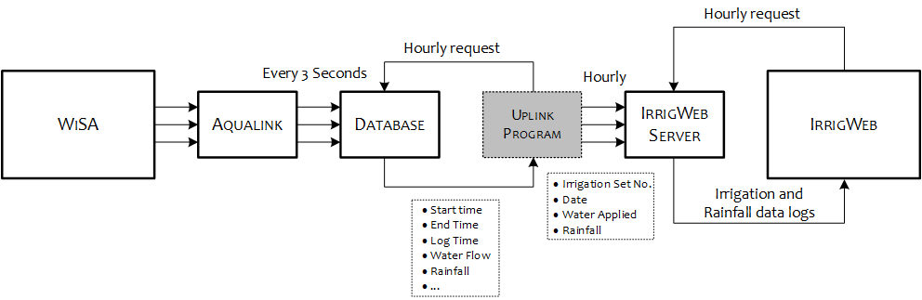

Figure 1 Uplink

The workflow for Uplink is as follows (with the red text representing how Uplink interacts with Aqualink, the green text representing how Uplink processes the data from Aqualink, and the blue text resenting how Uplink interacts with IrrigWeb):

1. Read a configuration file, with the information including number of hydraulic groups, and information for each hydraulic group, including irrigation type, pump, flow meter and valve IDs.
2. Use “*nxSQLExec*” to query Aqualink database “*ALConfig/Devices*” to obtain the information for each valve, including valve name (*DeviceN*), group ID (*HydGrp*), area (*LandArea*), design flow rate (*MinFlowRate/MaxFlowRate*), etc.
3. Use flow meter and valve IDs (*UID*) to query Aqualink database “*ALData/Outputlogs and ALData/SensorLogs*” to obtain the data within the query time frame (e.g., 01/04/2018 – 07/04/2018) for each hydraulic group, including the log time (*LogDT*) and log value (*SValue*) of the flow meter, and the start time (*StartDT*) and end time (*FinishDT*) of the valves.
4. Calculate the individual flow rate for each irrigation set at each log time:
   1. For drip sets, $f_{i}=f_{M}\frac{fs_{i}}{\sum_{i}{fs_{i}}}$ (litre/second), where $f_{i}$ is the individual flow rate for valve $i$, ${fs}_{i}$ is the design flow rate of valve $i$, $f_{M}$ is the flow rate of flow meter at this log time, and $\sum_{i}{fs_{i}}$ is the sum of the design flow rate of all the valves that are opened at this log time.
   2. For furrow sets, $f_{i}=f_{M}\frac{A_{i}}{\sum_{i}{A_{i}}}$ (litre/second), where $A_{i}$ (ha) is the area of the irrigation set $i$.
5. Calculate the irrigation water amount for each set,
   1. For the hydraulic group with a flow meter, $W_{i}=\sum_{t_{s}<t<t_{e}}{{(f}_{i_{t}}×I_{t}})$ (litre), where $W_{i}$ is the water amount, $f_{i_{t}}$ is the flow rate for valve $i$ at time $t$ between the start time $t_{s}$ and end time $t_{e}$, and $I_{t}$ is the time interval for each flow rate log (e.g., 300 seconds or 180 seconds).
   2. For the hydraulic group without a flow meter, $W_{i}=\sum_{t_{s}<t<t_{e}}{{(fs}_{i}×I_{t}})$ (litre).
6. Calculate the water applied, ${wa}_{i}=\frac{W_{i}}{A_{i}×10000}$ (mm).
7. The water applied for each irrigation set during the last 7-day is calculated and saved into a file named “*Famer ID*~*Farm name*.dat”, with the following format:

*Name,Date,Block,Water Applied (mm)*

*Home,05/02/2018,D2,6.91*

*Home,05/02/2018,D1,6.91*

*Home,05/02/2018,D3,5.31*

*Home,05/02/2018,D4,5.31*

*Home,05/02/2018,D5,0.00*

*Home,04/02/2018,D2,12.68*

*Home,04/02/2018,D1,12.68*

*Home,04/02/2018,D3,13.54*

*Home,04/02/2018,D4,13.54*

*Home,04/02/2018,D5,0.00*

*Home,03/02/2018,D2,16.70*

*Home,03/02/2018,D1,16.70*

*Home,03/02/2018,D3,13.82*

*Home,03/02/2018,D4,13.82*

*Home,03/02/2018,D5,0.00*

1. The file is uploaded to IrrigWeb FTP server folder “*/IrrgApp*”.
2. IrrigWeb server interrogates the FTP folder every hour and updates the irrigation data for each farmer.

# Downlink

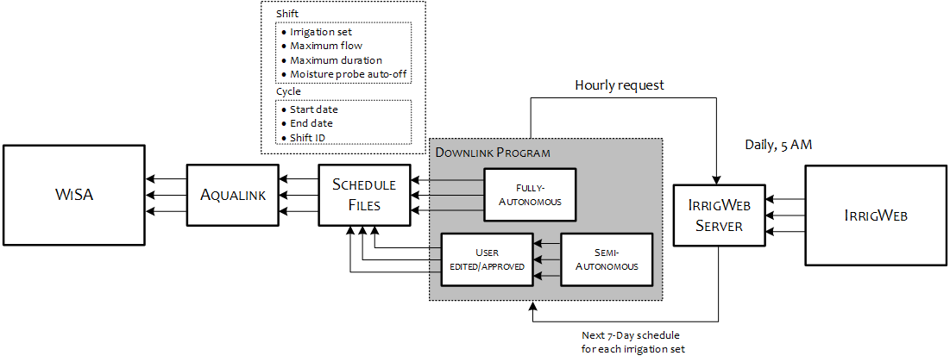

Figure 2 Downlink

As depicted in the figure Figure 2, Downlink works as follows (with the red text representing how Downlink interacts with Aqualink, the green text representing how Downlink processes the data from IrrigWeb, and the blue text representing how Downlink interacts with IrrigWeb):

1. Interrogate the IrrigWeb FTP server hourly and download the schedule file named “*famerID.dat*” from folder “*/IrrigSch*”, with the following format:

Farm name,Block,Date,Water required,SWDat the end of yesterday,CWUof today

Aaron's Farm,D1,2019-06-17,8.0,-50.824662245638876,3.2244427794053125

Aaron's Farm,D1,2019-06-18,5.8246622456388906,-48.225109702995084,3.2251097029950562

Aaron's Farm,D1,2019-06-19,3.2251097029950984,-48.225928130025352,3.225928130025371

Aaron's Farm,D1,2019-06-20,3.2259281300253662,-48.226898501918072,3.2268985019180807

Aaron's Farm,D1,2019-06-21,3.226898501918086,-48.228021061350276,3.2280210613503

Aaron's Farm,D1,2019-06-22,3.2280210613502902,-48.229295850605808,3.22929585060582

1. Calculate the SWD at the end of today for each irrigation set:

SWDat the end of today = SWDat the end of yesterday - CWUof today

1. Calculate the irrigation water required if the SWD of an irrigation set passes below the user-defined irrigation deficit threshold (TH):

Waterof today (mm) = TH – SWD at the end of today, if SWD at the end of today < TH;

1. Calculate the irrigation duration for each set based on the obtained irrigation water required and design flow rate $fs_{i}$ from Aqualink database;
2. Determine the irrigation priority based on the ratoon type, e.g., P>R1>R2>R3>R4;
3. Calculate irrigation schedule for each irrigation set based on the Tariff, pump capacity and the irrigation priority:
   1. Example 1, if there are 10 hours available today from 9pm – 7am, and D1 (ratoon P) requires 8-hour irrigation, and D2 (ratoon R1) requires 6-hour irrigation, the irrigation schedule would be:

9pm – 5am, D1;

5am-7am, D2;

* 1. Example 2, if there are 10 hours available today from 9pm – 7am, and D1 (ratoon P) requires 6-hour irrigation, D2 (ratoon R1) requires 4-hour irrigation, and D3 (which is a small block that can be irrigated at the same time with either D1 or D2) requires 8-hour irrigation, the irrigation schedule would be:

9pm – 3am, D1 and D3;

3am-5am, D2 and D3;

5am-7am, D2;

1. Create irrigation shifts and cycle files (with specific shift and cycle numbers) using on the Aqualink format;
2. Save the shifts and cycles to folder “*/WiSA7/nxdb/Data/shifts*”, e.g., a shift and a cycle for each irrigation schedule;
3. Detect if there is an irrigation event running on Aqualink by investigating “*Cycle Ident*” for each cycle files.
   1. If there is an irrigation event running, then check again in an hour until there is no irrigation event running;
   2. Force to kill “*Aqualink.exe*” in the process and restart “*Aqualink.exe*” again so the new shifts and cycles are applied.